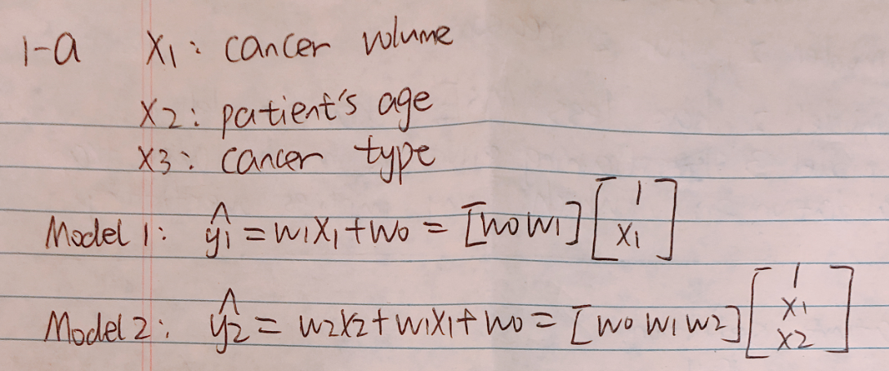

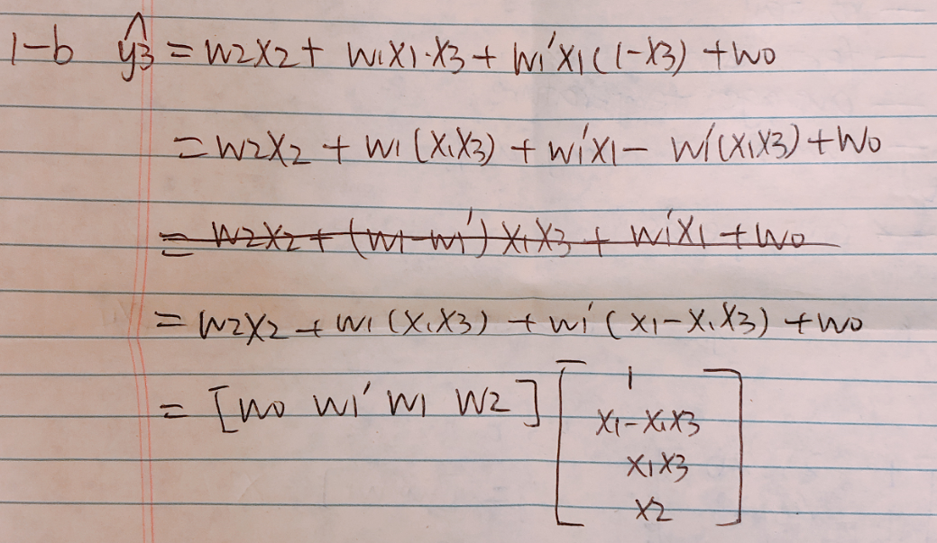

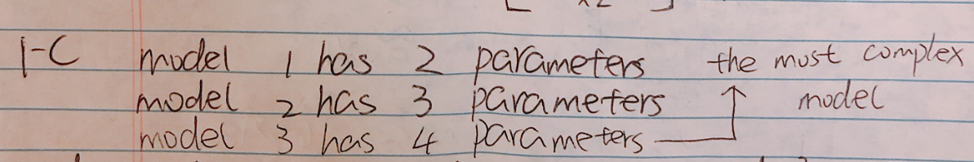

If we consider model 3, then it would be most complex model.

If we only consider model 1 and 2, then model 2 is more complex than model 1.

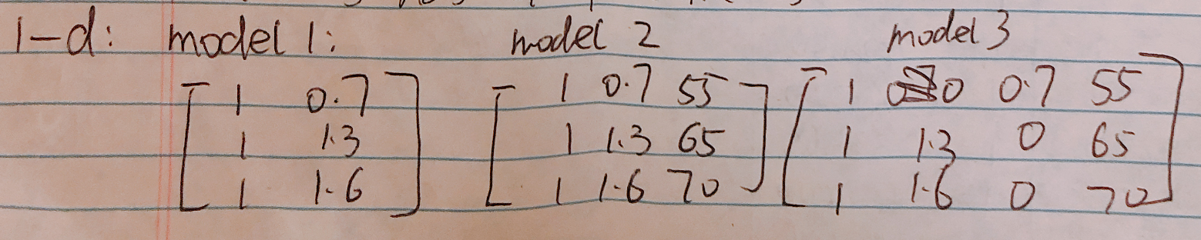

model 3 has 3 features: x1-x1\*x3, x1\*x3 and x2

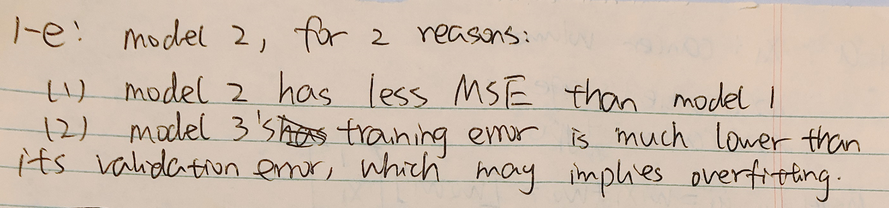

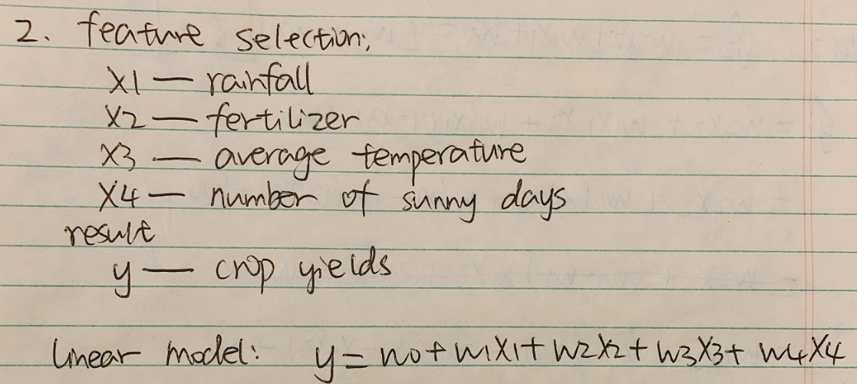

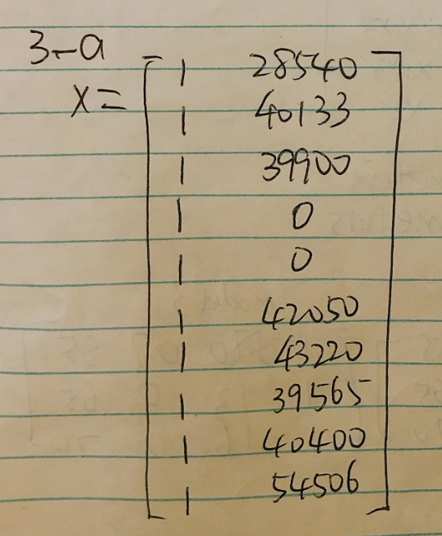

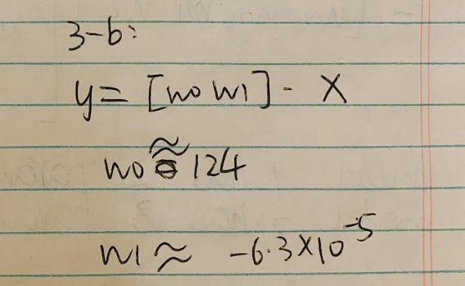

y = (-6.3\*10^(-5))\*x + 124

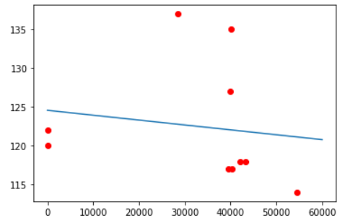

3-c before removing the noise

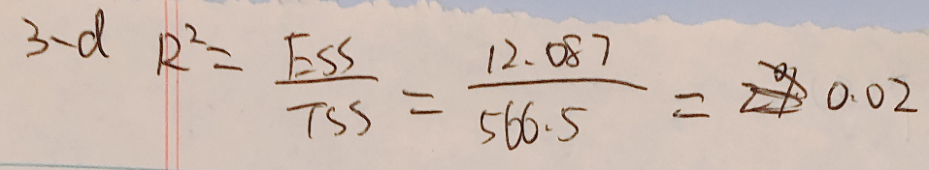

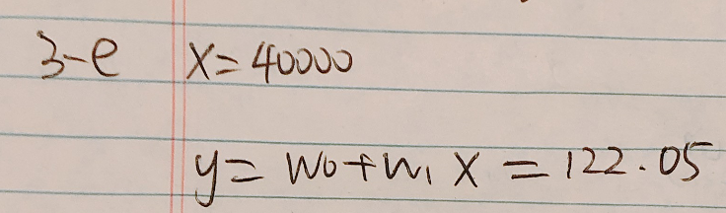

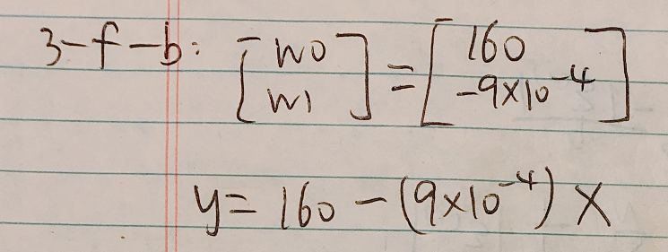

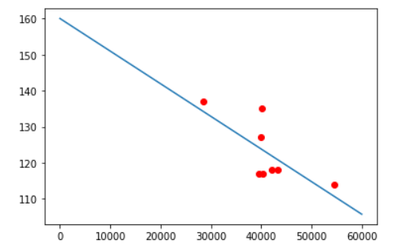

3-f-c after removing the noise

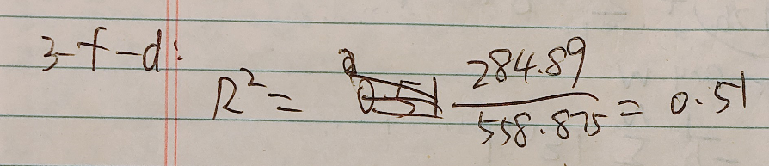

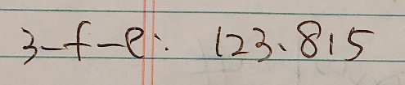

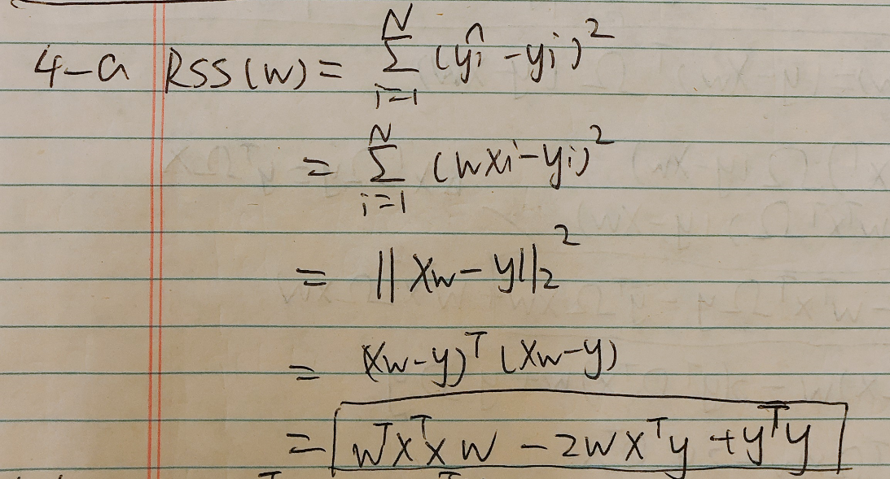

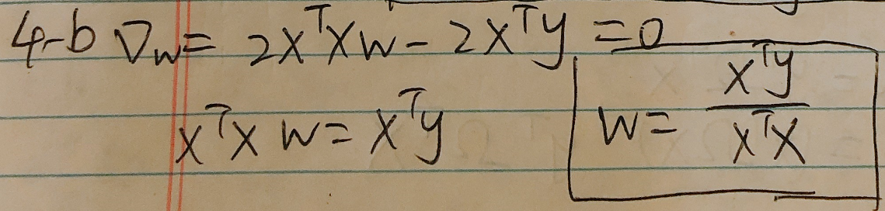

w is scalar, so I write in this way.

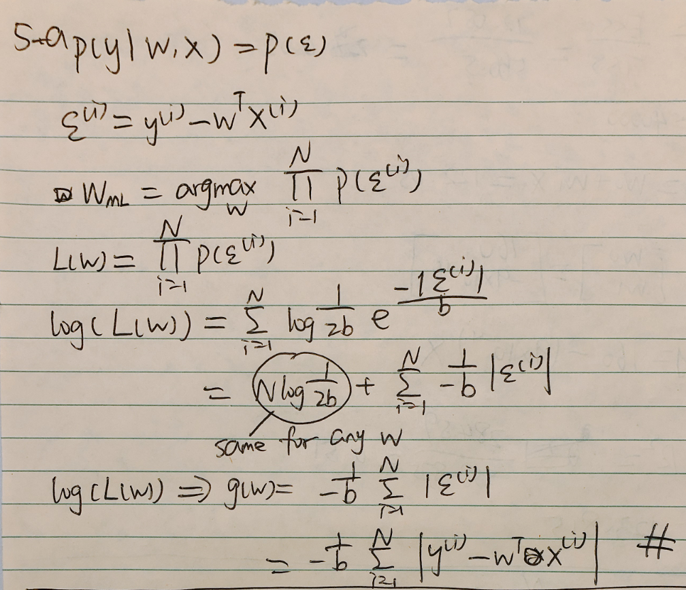

5-b

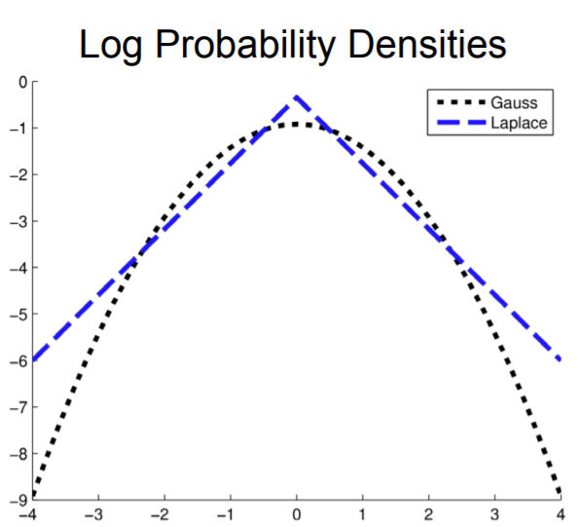

The picture above shows that the probability of noise data appearing in Laplace Distribution is higher than Gaussian Distribution.

One reason is that the log of the Laplace's PDF is an absolute polynomial, while the Gaussian is quadratic. The probability of Laplace decreases slower than the probability of Gaussian. Therefore, the noise data in Laplace has a higher probability than Gaussian.